CS 491 SDD

REBLOOM: SUSTAINABLE CIRCULAR FASHION PLATFORM

Table of Contents
1. INTRODUCTION 2
2. SOFTWARE DESIGN 2
2.1. SOFTWARE ARCHITECTURE 2
2.2. TOPOLOGY 3
2.3. MODULE STRUCTURE 4
2.4. INTERFACE DESIGN 9
2.5. CLASS DIAGRAMS 9
2.6. SEQUENCE DIAGRAMS 11
2.7. USER INTERFACE (UI) MOCKUPS 13
2.8. DATA DESIGN 14
2.9. TOOLS and TECHNOLOGY 19
3. PROJECT SCHEDULE 21

1. INTRODUCTION

The primary goal of the ReBloom project is to increase the adoption of circular fashion by addressing the two main barriers in the current second-hand market: the difficulty of finding specific visual styles via text-based search and the lack of immediate user motivation for sustainable behavior.

This project proposes a mobile application that integrates a Visual AI Search Engine which allows users to find items by uploading photos and a Gamified Water-Saving Visualization which is a digital tree that grows as users save water. This document details the architectural decisions, including the modular monolith design, decoupled AI service topology, and the database schema required to support these features.

2. SOFTWARE DESIGN

2.1. SOFTWARE ARCHITECTURE
The ReBloom system uses a client–server architecture based on a three-tier design, which is suitable for mobile application development.
System divided into three main layers:

Presentation Layer (Client):
This layer consists of the Mobile Application running on the user’s device. It is responsible for the user interface and handling user interactions.

Application Layer (Backend):
The Core Backend API contains the main business logic of the system. This includes user authentication, product and inventory management, shopping cart and checkout operations, gamification logic, and communication with external services

Data Layer:
The system uses a database to save user, product, and order information. For heavy tasks like image search, we use a separate AI Service. This split between the main backend and the AI component has several benefits:
Benefits of this architecture:
- Independent Scaling: AI tasks are resource-heavy and can be scaled without affecting the rest of the system.
- Focused Backend: The core API stays lightweight, focusing only on shopping and user data.
- Specialized Storage: The AI uses a Vector Index (FAISS) designed for image search, which works better outside a standard database.
- Improved Reliability: If the AI service has an issue, the main shop and user accounts continue to work.

With this architecture:
- The mobile application communicates only with the Core Backend API.
- The backend serves as a secure bridge between the app, the database, and the AI.
- Time-consuming or external operations, such as real-world tree planting requests, are handled asynchronously to avoid blocking the user experience.

2.2. TOPOLOGY
The system topology explains how the software components of ReBloom are deployed on different hardware and infrastructure resources, and how they communicate with each other.
Client Side
- Mobile Application
  - Runs on user devices (Android / iOS)
  - Provides the user interface
  - Communicates with the backend via HTTPS
Server Side (Cloud Environment)
- Core Backend API Server
  - Hosts RESTful API endpoints
  - Handles authentication, product management, checkout, gamification, and orchestration
  - Typically deployed as a container service on a virtual machine or cloud platform.
- Database Server
  - Relational database (e.g., PostgreSQL or MySQL)
  - Stores transactional and persistent data
  - Hosted as a managed database service or on a virtual machine.
- AI Inference Service Server
  - Handles image embedding, similarity search, and auto-tagging
  - Runs separately from the back end
  - Can be deployed on standart CPU or GPU-supported infrastructure
- Vector Index Storage
  - Stores image embeddings using FAISS or a similar vector indexing system
  - Used by only the AI Inference Service for similiarity search
- External Reforestation Partner API
  - Third-party service used for real-world tree planting
  - Called asynchronously by the backend when needed

Communication Flow
- The Mobile Application sends requests to the Core Backend API.
- The Core Backend API reads and writes data to the Database Server.
- For visual search and auto-tagging, the backend sends requests to the AI Inference Service.
- The AI Inference Service performs similarity searches using the Vector Index.
- When a user reaches the highest sustainability level, the backend communicates with the Reforestation Partner API in the background.
This topology ensures scalability, security, and clear separation of responsibilities across system components.

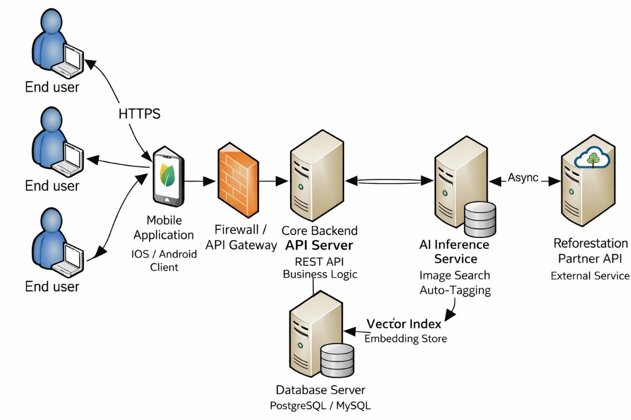

2.3. MODULE STRUCTURE
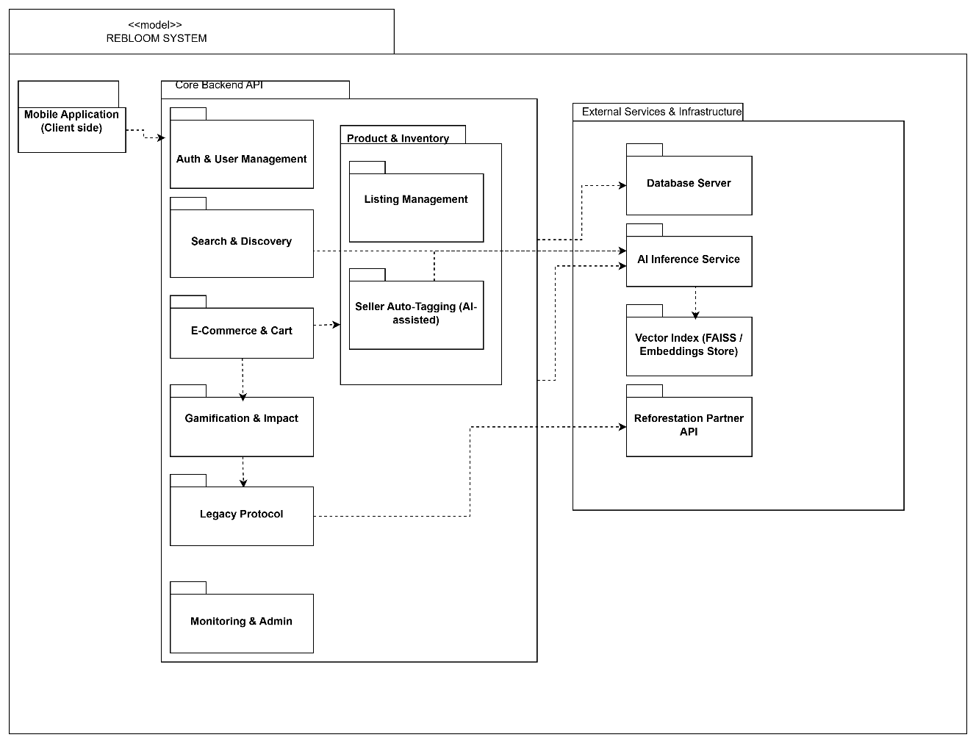

The ReBloom system is organised into several logical modules based on its main functional needs: user management, product listing, visual search, transaction processing, sustainability gamification, and real-world impact verification. This setup makes the system easier to maintain, lets team members work at the same time, and lets you run resource-heavy AI features independently.

1) Authentication & User Management Module

Purpose:
Manages user identity, authentication, and account lifecycle.

Responsibilities:

User registration and login

Token/session handling (e.g., JWT-based authentication)

Profile management (username, address, preferences)

Role management (Buyer / Seller / Admin)

Account-related actions (account deletion, data export for KVKK/GDPR compliance)

Main Data:
User, Role, UserSettings, SessionToken

Interfaces (Examples):

POST /api/auth/register

POST /api/auth/login

GET /api/users/{id}

PUT /api/users/{id}

2) Product & Inventory Module (Seller Side)

Purpose:
Handles seller listings and manages product availability within the system.

Responsibilities:

Create, update, and delete product listings

Maintain listing status (Active, Reserved, Sold)

Store and manage product metadata (category, size, brand, fabric type, condition, weight, price)

Prevent double-booking via inventory reservation and locking mechanisms

Sub-modules:

2.1 Listing Management

CRUD operations for product listings

Status transitions and lifecycle management

Image upload and association with listings

2.2 Seller Auto-Tagging (AI-assisted)

Automatically suggests listing attributes (e.g., category, color, pattern).

Pre-fills listing form fields for seller review and editing.

Uses the AI service for predictions.

Main Data:
Product, ProductImages, ListingStatus, InventoryLock, DraftListing, AutoTagResult

Interfaces (Examples):

POST /api/products

PUT /api/products/{id}

DELETE /api/products/{id}

GET /api/products/{id}

POST /api/ai/autotag (via backend → AI service)

3) Search & Discovery Module (User Side)

Purpose:
Enables users to discover products through both text-based and image-based search.

Responsibilities:

Keyword-based search and filtering (price, size, category, condition)

Combines AI search with standard filters.

Organizing search results by rank and page.

Display of product detail pages

Sends visual search requests to the AI Inference Service

Main Data:
SearchQuery, Filters, SearchResultsCache (optional)

Interfaces (Examples):

GET /api/search?text=...&size=...&priceMax=...

POST /api/search/visual

GET /api/products/recommendations

4) E-Commerce & Cart Module

Purpose:
Handles the complete purchasing workflow securely and consistently.

Responsibilities:

Shopping cart operations (add/remove items)

Making sure items are in stock and reserving them.

Payment processing (e.g., Stripe integration)

Finalize orders and mark items as sold

Notifies the system when an order is successfully completed (OrderCompleted event).

Main Data:
Cart, CartItem, Order, OrderItem, PaymentTransaction

Interfaces (Examples):

POST /api/cart/add

POST /api/cart/remove

POST /api/checkout

GET /api/orders/{id}

5) Gamification & Sustainability Impact Module

Purpose:
Motivates users by visually presenting their environmental impact within the application.

Functionality:
This module listens for completed order events from the E-Commerce & Cart module and updates its state accordingly.

Input:

Transaction data (item weight in kilograms, fabric type, item condition)

Core Logic:

Computes the total amount of water saved using the following formula:

$$W_{total}=∑(W_{footprint}×W_{weight}×ConditionFactor)$$

Updates the user’s cumulative impactScore in the database.

Uses predefined thresholds to decide the current tree stage based on the updated score.

Seed: 0 < score < 100 L

Sapling: 100 ≤ score < 5,000 L

Young Tree: 5,000 ≤ score < 20,000 L

Mature Oak: score ≥ 20,000 L

Ancient Oak: score ≥ 100,000 L

Output:

Triggers real-time UI updates to visually grow the user’s Digital Tree

Updates leaderboard statistics and progress indicators

Triggers a TreeMaxedOut event when the Ancient Oak level is reached.

6) Legacy Protocol Module (Real-World Impact Verification)

Purpose:
Links virtual success to real environmental results.

Functionality:

Waits for the TreeMaxedOut event triggered by the Gamification & Impact module.

Creates a unique ID for the certificate and saves it in the database.

Sends an API request to the external Reforestation Partner Service to request tree planting

User Feedback:

Notify the user once the confirmation is received.

May include metadata such as confirmation status and GPS coordinates of the planting site (if provided)

Main Data:
Certificate, PartnerRequestLog

7) AI Inference Service (Decoupled Service)

Purpose:
Provides visual search and tagging features using machine learning as a separate service.

Responsibilities:

Check that the uploaded image is the right type and is the right size.

Extract visual features using an image embedding model (MobileNetV2 )

Perform similarity search using a Vector Index (FAISS / embeddings store)

Return top-K similar product IDs with confidence scores

Generate auto-tagging predictions for seller listings

Main Data:
ModelArtifacts, Embeddings / VectorIndex

Interfaces (Examples):

POST /api/ai/search

POST /api/ai/autotag

Note:
The AI Inference Service depends on the Vector Index for similarity search and does not directly depend on the relational Database Server.

8) Monitoring & Admin Module

Purpose:
Provides basic administrative control and helps monitor the overall system status.

Responsibilities:

Monitor system health (uptime, latency, error rates)

Keep audit and activity logs

Moderate users and product listings

Main Data:
AuditLog, SystemMetric, Report

Interfaces (Examples):

GET /api/admin/metrics

GET /api/admin/logs

POST /api/admin/moderate

Module Interaction Summary

User requests start from the Mobile Application and are handled by the Core Backend API. The backend stores and retrieves data from the Database Server. Visual search and seller auto-tagging requests are sent to the AI Inference Service, which uses the Vector Index to find similar products or generate predictions. After a successful checkout, an OrderCompleted event triggers the Gamification & Sustainability Impact module to update the user’s impact score and Digital Tree. When the highest sustainability level is reached, the Legacy Protocol module sents a background request to Reforestation API to trigger a real tree planting.

2.4. INTERFACE DESIGN
1. Team Roles (Module Ownership)

Member A (AI Specialist):
Responsible for designing and implementing the AI Inference Service, including image embedding extraction, similarity search logic, and the Vector Index (FAISS).

Member B (Frontend & Gamification):
Responsible for the Mobile Application UI and the Gamification & Sustainability Impact logic, including Digital Tree rules, thresholds, and leaderboard behavior.

Member C (Backend & Integrator):
Responsible for the Core Backend API, database access, authentication, e-commerce flow, and integration between backend, AI service, and external systems.

2. How the Application Communicates (Interface Contracts)
A) Mobile Application → Core Backend API

The Mobile Application communicates only with the Core Backend API using RESTful HTTP interfaces.
It does not directly access the database or the AI service.

Handled operations include:

Account management: login, registration, profile updates

Shopping flow: product browsing, cart management, and checkout

Search: text-based and image-based product search

Gamification: retrieving user impact score and leaderboard data

B) Core Backend API → AI Inference Service

When advanced visual analysis is required, the backend sends requests to the AI Inference Service via dedicated APIs:

Visual Search: image → similar product IDs

Auto-Tagging: image → predicted attributes (category, color, pattern)

The AI service processes these requests independently and returns results to the backend.

C) Internal AI Processing

Inside the AI Inference Service, a Vector Index (FAISS) is used to perform fast similarity searches between image embeddings.
This process is fully contained within the AI subsystem.

D) Internal Event-Based Triggers

Some actions occur automatically inside the backend using internal events:

After a successful checkout, an OrderCompleted event triggers the Gamification Module.

When the Digital Tree reaches its maximum level, a TreeMaxedOut event triggers the Legacy Protocol Module.

These interactions are not exposed to the Mobile Application.

E) Legacy Protocol → External Partner

The Legacy Protocol Module communicates asynchronously with an external Reforestation Partner API to initiate real-world tree planting.
Once confirmed, the system stores certification data and notifies the user.

3. Key Design Constraints

AI Independence: The AI Inference Service does not access the backend or database directly; it only responds to requests.

Security: The Database Server is accessible only through the Core Backend API.

Asynchronous Processing: Real-world actions such as tree planting are handled in the background to avoid blocking the user experience.

Operation | Caller (Initiator) | Owner (Responsible) | Expected Outcome
Login / Registration | Mobile Application | Member C (Backend & Auth) | Secure user authentication and session creation
Visual Search | Mobile Application | Member C (Backend) → Member A (AI Service) | List of visually similar product IDs with confidence scores
Purchase / Checkout | Mobile Application | Member C (E-Commerce & Inventory) | Order confirmation and inventory status update
Tree Growth (Gamification) | System (OrderCompleted event) | Member B (Gamification Logic) | Updated environmental impact score and Digital Tree stage
Real-World Tree Planting | System (TreeMaxedOut event) | Member C (Legacy Protocol & Partner Integration) | Verified real-world tree planting and certificate generation
Table 1- summarizes the main system operations, their initiators, responsible team members, and expected outcomes.

2.5. CLASS DIAGRAMS
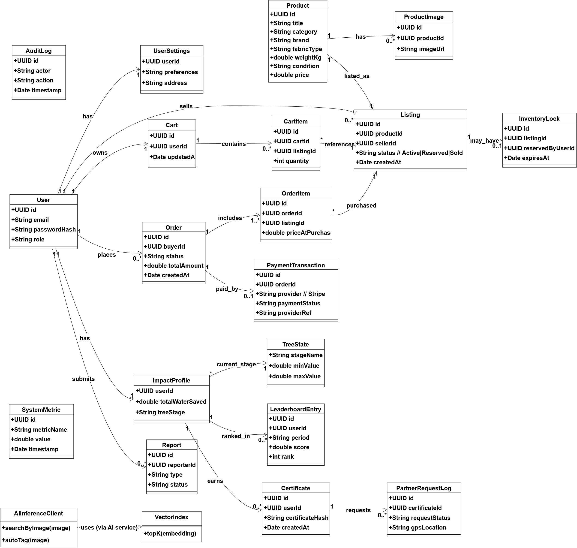

Figure 1 shows the high-level class diagram of the ReBloom system.
The diagram presents the main domain entities and their relationships across core modules such as user management, product listing, e-commerce, gamification, and real-world impact tracking.
Only key classes and associations are included to keep the diagram readable; implementation details and low-level helper classes are intentionally excluded.

2.6. SEQUENCE DIAGRAMS
1-Diagram Title: Sequence Diagram for Purchase & Tree Growth Flow
Actors & Objects:
- User (Actor)
- Mobile App (UI)
- CheckoutService (Backend API)
- GamificationEngine (Internal Module)
- UserDatabase (DB)
Description of Flow (Draw arrows for these steps):
- User clicks "Pay Now" → Mobile App.
- Mobile App sends POST /api/checkout → CheckoutService.
- CheckoutService processes payment (Stripe Success).
- CheckoutService calls internal method calculateImpact(items) → GamificationEngine.
- GamificationEngine calculates water saved using the equation.
- GamificationEngine queries SELECT score FROM User_Impact → UserDatabase.
- GamificationEngine determines state change (e.g., "Sapling" → "Young Oak").
- GamificationEngine updates DB UPDATE User_Impact SET score = newScore, state = 'Young Oak' → UserDatabase.
- GamificationEngine returns ImpactResult { saved: 12500, newLevel: "Young Oak" } → CheckoutService.
- CheckoutService returns HTTP 200 OK + AnimationPayload → Mobile App.
- Mobile App triggers "Tree Growth" animation on screen
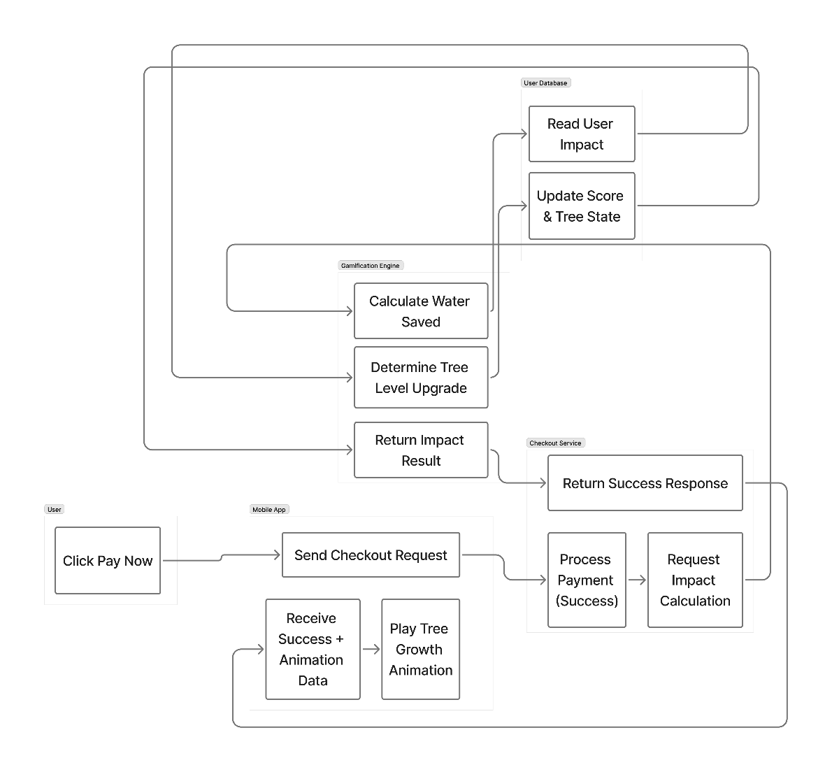

2-Diagram 2: Visual Search Flow
Actors & Objects:
- User (Actor)
- Mobile App (UI)
- VisualSearchService (Backend API)
- AI_Engine (TensorFlow/ResNet50)
- VectorDB (FAISS Index)
- ProductDB (PostgreSQL)
Description of Flow (Draw arrows for these steps):
- User uploads image → Mobile App.
- Mobile App sends POST /api/search with image → VisualSearchService.
- VisualSearchService sends image to AI_Engine.
- AI_Engine processes image and extracts FeatureVector → returns Vector to VisualSearchService.
- VisualSearchService queries findNearest(FeatureVector) → VectorDB.
- VectorDB returns list of ProductIDs → VisualSearchService.
- VisualSearchService queries details for these IDs → ProductDB.
- ProductDB returns Product Metadata (Name, Price, ImageURL) → VisualSearchService.
- VisualSearchService returns JSON List of Products → Mobile App.
- Mobile App displays "Results Grid" to User.

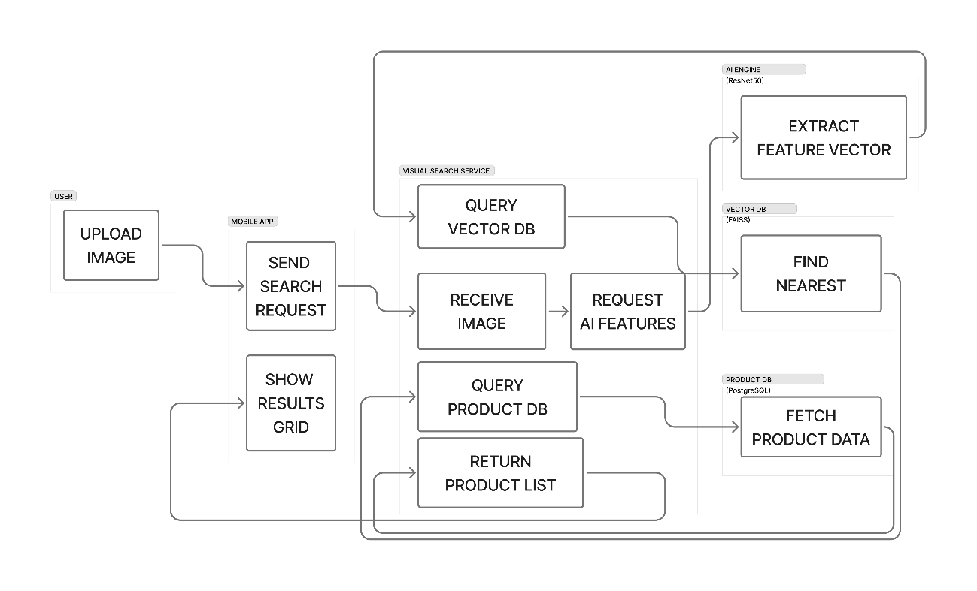

2.7. USER INTERFACE (UI) MOCKUPS

  - The Lens Tab: A camera interface with an overlay to "Snap or Upload" a photo.
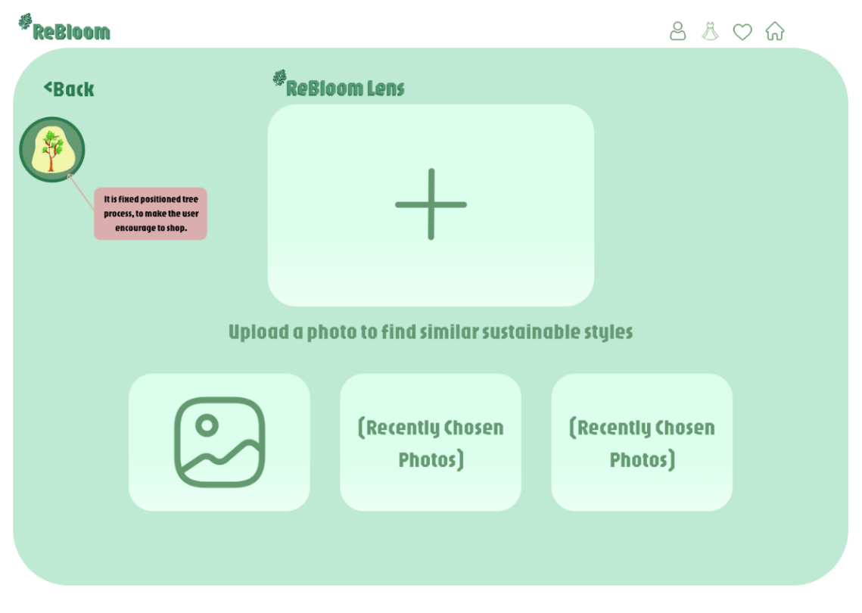
  - The Results Grid: A Pinterest-style staggered grid showing the AI matches.
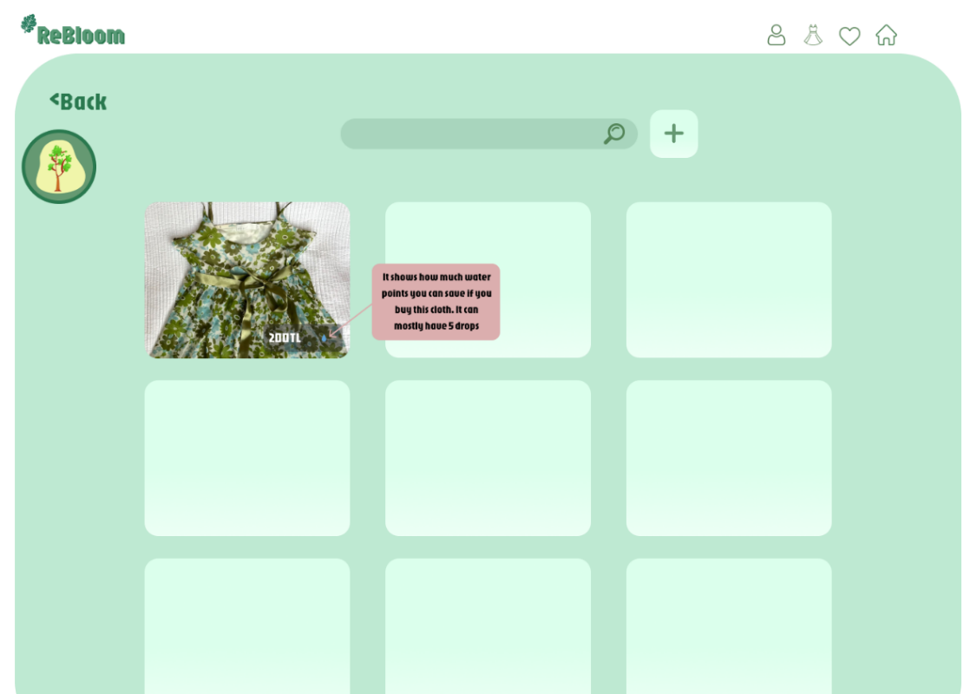
  - The Profile/Tree: A dashboard showing the user's current tree (animated) and a progress bar for the next level.
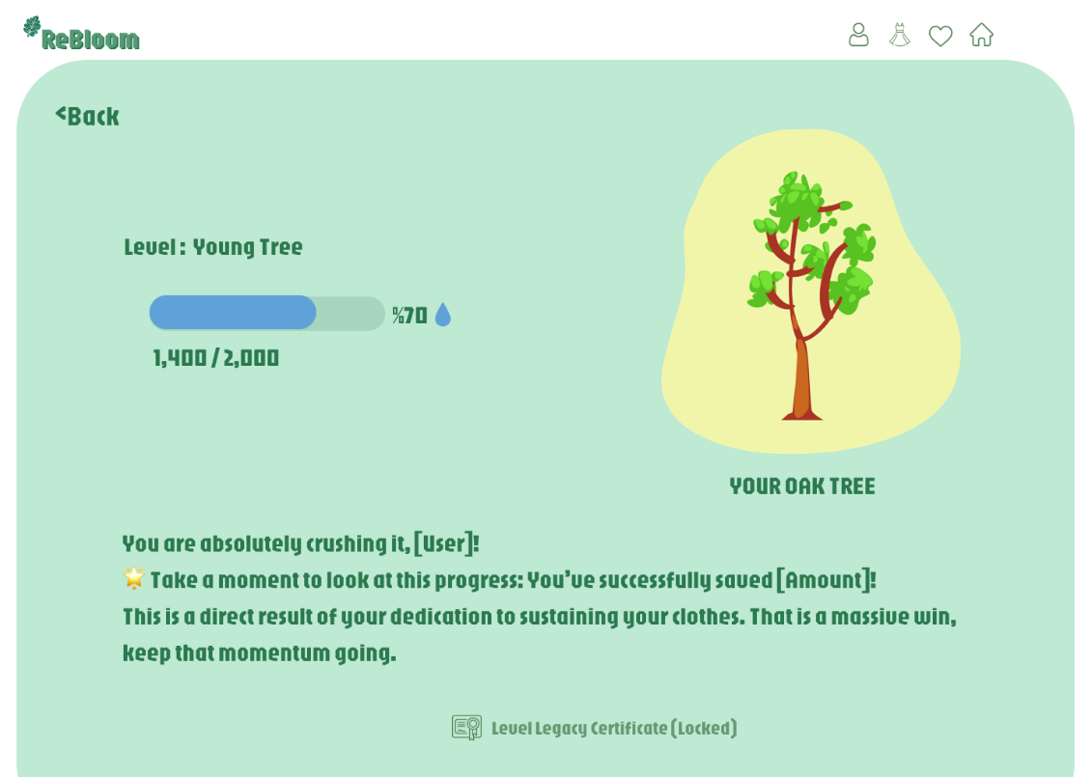

  - The Impact Leaderboard: A list showing "Top Savers" in the community.
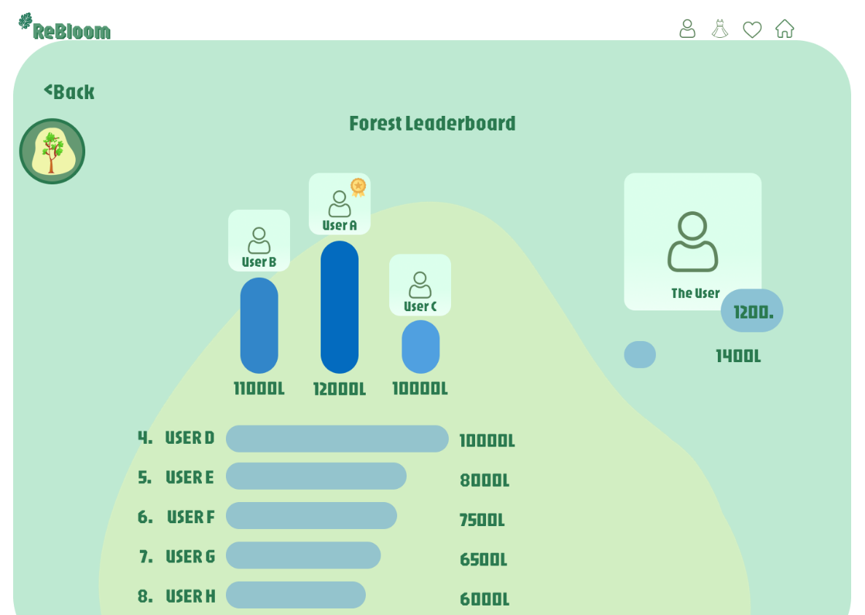

2.8. DATA DESIGN

2.8.1 Main Tables and Data Structures

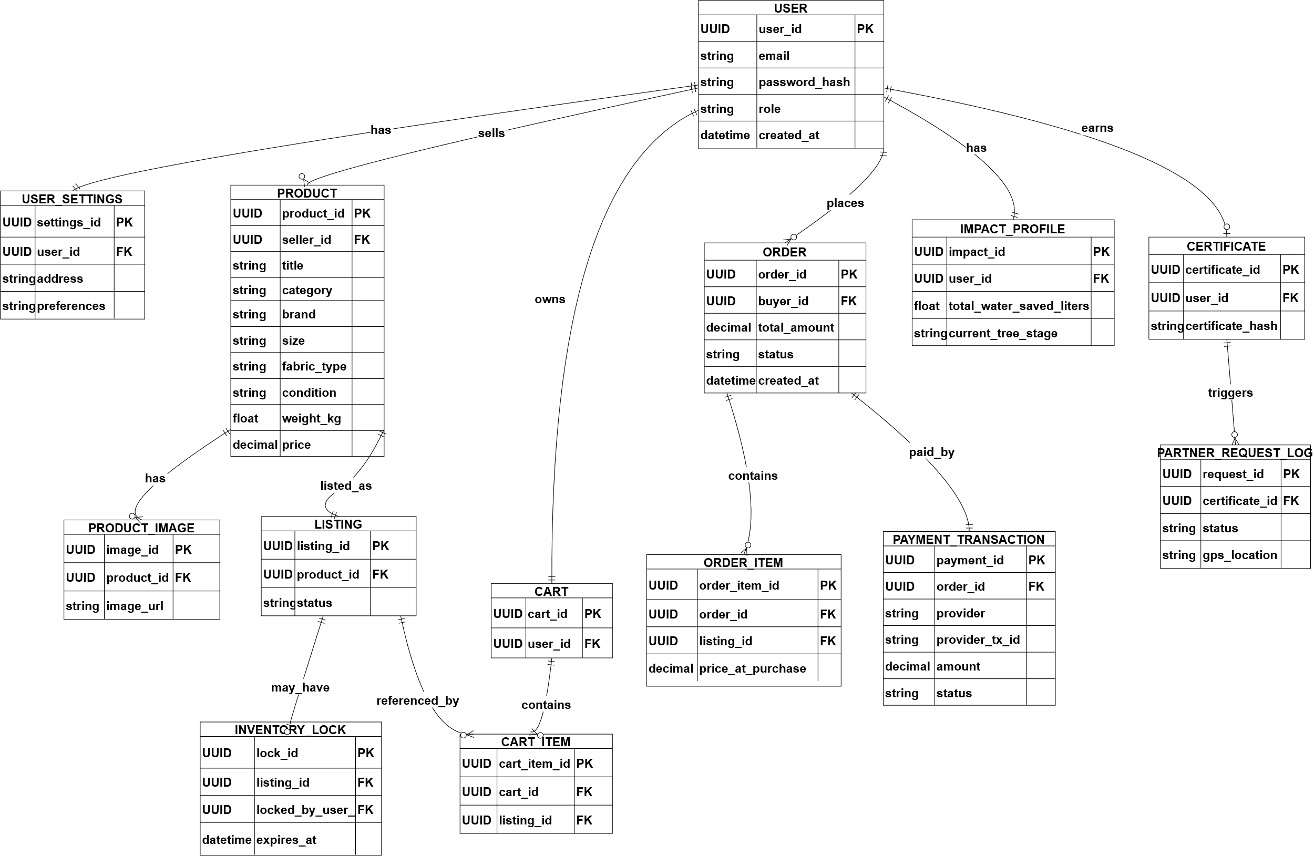

The ReBloom system uses a relational database to store core information such as users, products, orders, and sustainability impact data. The AI Inference Service is a separate part of the system and does not need to use the relational database. Instead, it manages similarity-related data using a vector index. This makes sure that transactional data is always handled in the same way, while allowing the AI to grow and work on its own.
User
Stores account and identity information for all users.
- user_id (PK): UUID
- email: string (unique)
- password_hash: string
- role: enum (Buyer / Seller / Admin)
- created_at: datetime
UserSettings
Stores user preferences and profile-related settings.
- settings_id (PK): UUID
- user_id (FK → User.user_id)
- address: string (optional)
- preferences: text / JSON (optional)

Product
Represents an item being sold (the core product record).
- product_id (PK): UUID
- seller_id (FK → User.user_id)
- title: string
- category: string
- brand: string (optional)
- size: string
- fabric_type: string
- condition: string / enum
- weight_kg: float
- price: decimal
- created_at: datetime
ProductImage
Stores image references for a product (multiple images per product).
- image_id (PK): UUID
- product_id (FK → Product.product_id)
- image_url: string
- uploaded_at: datetime

Listing
Controls the selling lifecycle/status of a product.
- listing_id (PK): UUID
- product_id (FK → Product.product_id)
- status: enum (Active / Reserved / Sold)
- created_at: datetime
- updated_at: datetime
InventoryLock
Prevents two users from buying the same item at the same time.
- lock_id (PK): UUID
- listing_id (FK → Listing.listing_id)
- locked_by_user_id (FK → User.user_id)
- expires_at: datetime

Cart
Stores an active shopping cart for a user.
- cart_id (PK): UUID
- user_id (FK → User.user_id)
- created_at: datetime
CartItem
Items inside the cart (each item references a listing).
- cart_item_id (PK): UUID
- cart_id (FK → Cart.cart_id)
- listing_id (FK → Listing.listing_id)
- quantity: int (typically 1 for second-hand items)

Order
Stores a completed purchase.
- order_id (PK): UUID
- buyer_id (FK → User.user_id)
- total_amount: decimal
- status: enum (Pending / Paid / Failed / Cancelled)
- created_at: datetime
OrderItem
Stores purchased items under an order.
- order_item_id (PK): UUID
- order_id (FK → Order.order_id)
- listing_id (FK → Listing.listing_id)
- price_at_purchase: decimal
PaymentTransaction
Stores payment-related information (e.g., Stripe transaction reference).
- payment_id (PK): UUID
- order_id (FK → Order.order_id)
- provider: string (e.g., Stripe)
- provider_tx_id: string
- amount: decimal
- status: enum (Success / Failed / Refunded)
- created_at: datetime

ImpactProfile
Stores each user’s cumulative sustainability impact score.
- impact_id (PK): UUID
- user_id (FK → User.user_id)
- total_water_saved_liters: float
- current_tree_stage: enum (Seed / Sapling / Young Tree / Mature Oak / Ancient Oak)
- updated_at: datetime
TreeState
Stores stage definitions and thresholds (can also be hardcoded, but keeping it as data makes it easier to update).
- stage_id (PK): UUID
- stage_name: string
- min_score: float
- max_score: float (optional for top tier)
LeaderboardEntry
Stores leaderboard snapshots (e.g., monthly ranking).
- entry_id (PK): UUID
- user_id (FK → User.user_id)
- period: string (e.g., “2025-05”)
- water_saved_liters: float
- rank: int

Certificate
Created when a user reaches the maximum level and triggers real-world verification.
- certificate_id (PK): UUID
- user_id (FK → User.user_id)
- certificate_hash: string (unique)
- created_at: datetime
PartnerRequestLog
Logs calls made to the external reforestation partner API.
- request_id (PK): UUID
- certificate_id (FK → Certificate.certificate_id)
- status: enum (Sent / Confirmed / Failed)
- partner_response: text (optional)
- gps_location: string (optional)
- created_at: datetime

AuditLog / SystemMetric / Report (Admin & Monitoring)
Used for moderation and system monitoring.
- AuditLog: admin actions, important events
- SystemMetric: uptime, latency, error rates (stored periodically)
- Report: user/listing reports for moderation

2.8.2 AI Data (Non-Relational)
The AI Inference Service does not directly access the relational database. Instead, it maintains:
- Vector Index (FAISS / embeddings store): stores feature vectors for product images
- Model Files: The pre-trained AI files that know how to recognize and label photos.
The Core Backend API sends the required inputs, such as image files, to the AI service and then uses the returned product IDs to retrieve full product information from the database.
2.8.3 Data Relationship Summary
- A User can create many Products and Listings (as a seller) and can place many Orders (as a buyer).
- A Product can have many ProductImages and typically maps to one active Listing.
- A Cart contains multiple CartItems, each referencing a Listing.
- An Order includes multiple OrderItems and has one related PaymentTransaction.
- An ImpactProfile is maintained per user and can generate a Certificate and PartnerRequestLog when the maximum tree stage is reached.

2.9. TOOLS and TECHNOLOGY

ReBloom is a mobile application that combines a second-hand marketplace with image-based search and sustainability-related features. The selected technologies aim to keep the system modular, easy to understand, and suitable for a small student team working in parallel.

Mobile Application (Client)

Technology: React Native (Expo), JavaScript/TypeScript

Reason for choice:
React Native simplifies mobile application development by providing a flexible framework and a large set of reusable UI components. It allows for faster development and simpler maintenance, which is ideal for a student project with a limited schedule.

Core Backend API
Technology: Python (FastAPI)
Reason for choice:
FastAPI handles everything from user accounts to shopping and rewards. It provides a clean structure for building the system and automatically creates documentation. This makes it much easier for team members to connect their work and understand how the API works.
Database Server
Technology: PostgreSQL (relational database)
Reason for choice:
ReBloom has strong transactional needs (orders, cart items, inventory locks, payments). A relational database provides data consistency, constraints, and reliable relationships (e.g., user → order → order items). PostgreSQL is widely used, stable, and suitable for structured marketplace data.

AI Inference Service
Technology: Python-based ML service
Reason for choice:
Image-based search and auto-tagging require additional processing and machine learning libraries. By keeping the AI as a separate service, we keep the main backend fast and allow the AI components to be updated without affecting the rest of the app.
Image Embedding Model
Technology: MobileNetV2 (feature extractor)
Reason for choice: MobileNetV2 is efficient and lightweight, making it a practical choice for fast feature extraction with limited computational resources. It gives us great image search results without needing expensive or heavy hardware.

Vector Similarity Search
Technology: FAISS / Vector Index (Embeddings Store)
Reason for choice: Visual similarity search works by comparing image embeddings. A vector index like FAISS is optimized for this type of search and is more suitable than a relational database. For this reason, embeddings are stored separately from the main database.

External Integrations
Payments: Stripe (planned integration)
Reason for choice: Stripe provides a standard and secure approach for payment processing and supports common checkout flows.
Reforestation Partner API: External HTTP API (async integration)
Reason for choice: Tree planting is handled by an external service. The system sends requests in the background and updates records after confirmation without interrupting the user experience.

Development & Deployment Tools
Version Control: Git + GitHub
Reason for choice: Enables collaboration, branching, code reviews, and integration between modules.
API Testing: Postman / Swagger (FastAPI auto-docs)
Reason for choice: These tools automatically document our API, making it easy to test our features and ensure different parts of the app connect correctly.
Containerization (optional): Docker
Reason for choice: Ensures the app runs exactly the same way on everyone’s computer, avoiding "it works on my machine" errors by packaging all necessary files together.

3. PROJECT SCHEDULE

The ReBloom project is developed by a three-person team. To enable parallel development and smooth integration, responsibilities are divided based on system modules. Each team member is responsible for implementing, testing, and delivering code related to their assigned modules. Integration is performed collaboratively at defined milestones.

Member A – AI & Visual Search Development
Member A is responsible for implementing all AI-related functionality in the system.
Responsibilities:
- Develop the AI Inference Service as a separate backend service
- Implement image-based visual search (similarity search)
- Generate image embeddings using MobileNetV2
- Build and manage the vector index (FAISS)
- Provide prediction results for seller auto-tagging
- Implement AI-related API endpoints (/api/ai/search, /api/ai/autotag)
Deliverables:
- AI inference service with working REST endpoints
- Embedding generation logic
- Vector index populated with sample product embeddings

Member B – Frontend & Gamification Development
Member B is responsible for developing the mobile application and implementing the sustainability gamification logic.
Responsibilities:
- Develop the mobile application using React Native
- Implement frontend logic for user flows (login, search, cart, profile)
- Implement the Gamification & Sustainability Impact logic
- Code Digital Tree state transitions based on impact thresholds
- Implement leaderboard calculation and impact visualization
- Integrate frontend with backend APIs
- Implement user notifications and feedback screens
Deliverables:
- Functional mobile application screens
- Frontend logic for gamification and impact visualization
- Integrated UI connected to backend services

Member C – Backend & System Integration
Member C is responsible for core backend services and overall system integration.
Responsibilities:
- Develop the Core Backend API
- Implement Authentication & User Management
- Implement Product & Inventory module
- Implement E-Commerce & Cart module
- Handle order processing and system events (OrderCompleted)
- Integrate AI Inference Service and external partner services
- Design and manage the database schema and persistence layer
Deliverables:
- Backend REST API endpoints
- Database schema and CRUD operations
- Checkout flow and order processing logic
- Integration with AI service and Reforestation Partner API

Milestones & Integration Plan

Milestone 1 – Core Setup
- Basic backend API structure
- Initial database schema
- Mobile app skeleton
- AI service skeleton

Milestone 2 – Feature Implementation
- Product listing and search features
- Visual search integration
- Cart and checkout logic
- Gamification logic implementation

Milestone 3 – Integration & Testing
- Full frontend-backend integration
- AI service integration
- Gamification and legacy protocol testing
- System testing and bug fixing

Final Notes:
All team members take part in testing, debugging, and final integration to make sure that the system works as a whole. Using multiple milestones helps the team identify integration problems early and makes sure that each module is tested step by step. Clearly defined responsibilities and interfaces also make collaboration easier and help the team deliver a stable and well-integrated final system.

